1. HTML Web Technologies
   1. Java Script
   2. HTTP Status Codes
2. Database and Queries
3. Troubleshooting skills
4. Operating Systems and Unix

Onsite Round  4 45-minute interviews, 2 non-technical, 1 more technical, and 1 completely technical coding interview.

<https://medium.com/@maneesha.wijesinghe1/what-happens-when-you-type-an-url-in-the-browser-and-press-enter-bb0aa2449c1a>

<https://www.youtube.com/watch?v=7_LPdttKXPc&feature=youtu.be>

When you type maps.google.com in your browser, what happens?

1. Client/Server, Consumer/Producer. Clients are Laptops/desktop/devices connected to internet through ISP. Servers are connected directly to Internet, since they are provider/producer of data.
2. The Providers/Producers/Server has an unique ip address and host-name, registered at DNS.
3. DNS(Domain Name System) is a database that maintains the name of the website (URL) and the particular IP address. Need some way to get this ip address.
4. The browser checks the cache (four caches) for a DNS record to find the corresponding IP address. Caches are important for regulating network traffic and improving data transfer times.
   1. browser cache
   2. OS cache
   3. router cache
   4. ISP cache
5. If the requested URL is not in the cache, ISP’s DNS server initiates a DNS query to find the IP address of the server that hosts maps.google.com. It is also called DNS lookup process. It is a recursive query. Ex: For maps.google.com, first, the DNS will contact the root name server (.*). The root name server will redirect it to **.com** domain name server. **.com** name server will redirect it to **google.com** name server. **google.com** name server will find the matching IP address for maps.google.com in its’ DNS records which will send it back to your browser.
6. 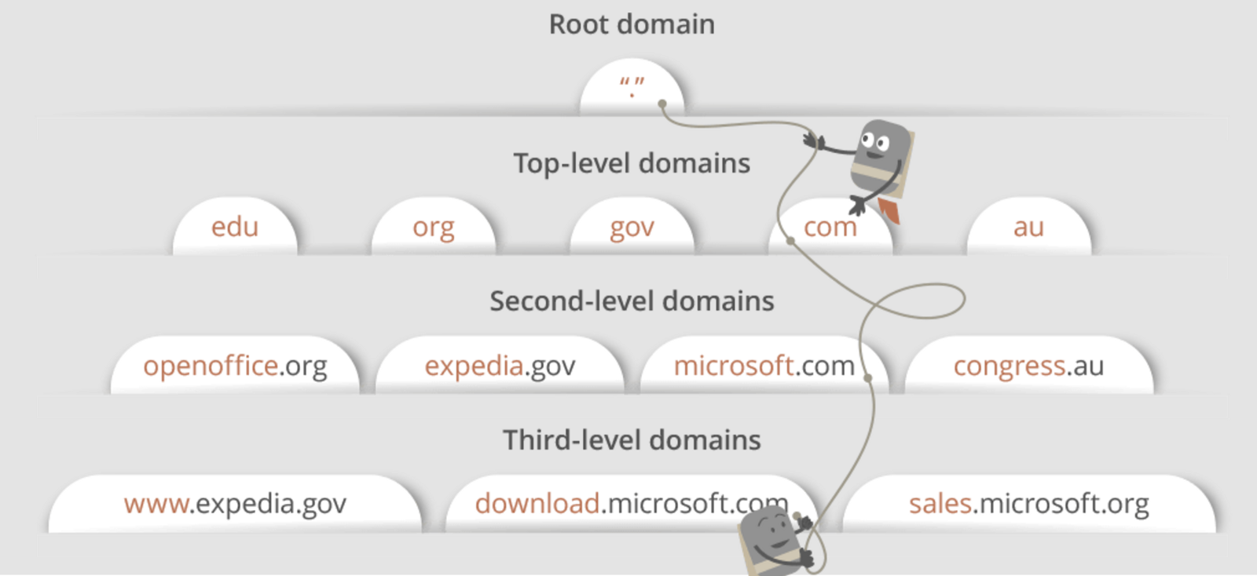
7. **Browser initiates a TCP connection with the server.**
   1. This connection is established using a process called the TCP/IP three-way handshake. This is a three step process where the client and the server exchange SYN(synchronize) and ACK(acknowledge) messages to establish a connection.
   2. 1. Client machine sends a SYN packet to the server over the internet asking if it is open for new connections.
   3. 2. If the server has open ports that can accept and initiate new connections, it’ll respond with an ACKnowledgment of the SYN packet using a SYN/ACK packet.
   4. 3. The client will receive the SYN/ACK packet from the server and will acknowledge it by sending an ACK packet.
   5. Then a TCP connection is established for data transmission!
8. The browser sends an HTTP request to the web server.
9. The server handles the request and sends back a response.
10. The server sends out an HTTP response.
    1. ● 1xx indicates an informational message only
    2. ● 2xx indicates success of some kind
    3. ● 3xx redirects the client to another URL
    4. ● 4xx indicates an error on the client’s part
    5. ● 5xx indicates an error on the server’s part
11. The browser displays the HTML content in phases. First, it will render the bare bone HTML skeleton. Then it will check the HTML tags and sends out GET requests for additional elements on the web page, such as images, CSS stylesheets, JavaScript files etc. These static files are cached by the browser so it doesn’t have to fetch them again the next time you visit the page.
12. Note:
    1. From Server, Every Info is split/broken as packet and sent to client. Client Re-Assembles the packet to form original message.
    2. Router makes the packets to reach the destination faster by using shortest path algorithm